**Candidate Pack**

**Director of Fundraising & Marketing**

**(Salary - £65,208 - £70,699 per year pro-rata depending on skills and experience, 35 hrs a week, current location Victoria, remote/flexible working offer)**

**Welcome letter from the Chief Executive**

Thank you for your interest in this role at Buttle UK. This is a significant time for Buttle UK as we continue to step up support for children who have been hardest hit by the Cost of Living crisis.

We believe that Buttle UK is a special organisation, because of the direct difference we can make in the lives of vulnerable children and young people by providing items and activities that they are living without. We are proud of the innovative approach we have taken to provide this support, and the efficiency with which we do it. We are also proud of being a forward looking and externally focused organisation that seeks to use the unique insights gained through our grant giving for the wider benefit of children and young people in poverty.

Last year we were able to provide £4.3m in grant funding for children and young people, and we have increased this level of support to £5.5m in 2023-24, in response to the continuing cost of living crisis.

Our Chances for Children grants pay for normal things that we would want all children and young people to have, but their parent/s or carers cannot otherwise afford. Not extraordinary, but critical things in their lives. There has never been a greater need for the creative grant giving for which Buttle UK is known.

I hope you would like to play a part with us in supporting children and young people in crisis and I look forward to hearing from you.

**Joseph Howes**

**Chief Executive, Buttle UK**

**The Role**

This is an exciting time for Buttle UK during a period of sustained growth.  We are now ready, with your help to take our aspirations to the next level and invest further to ensure we continue a higher level of grant support, using fundraising income to power this alongside our endowment. We feel this is a unique opportunity, there are very few organisations that have an endowment and have developed a fundraising focus alongside it. We are seeking an exceptional **Director of Fundraising & Marketing** to invest in, grow and develop Buttle UK’s income streams.  We are looking for a leader who can inspire support via individual giving, corporates, major donors, trusts and events. Working with your team and PR Agency, InHouse, the successful candidate will be an outstanding relationship builder who can increase Buttle UK’s reach and profile by successfully communicating the impact of our work.

Our ideal candidate is an ambitious and experienced leader who possesses a proven track record of leading highly successful fundraising and communications teams.  You will be a proactive self-starter with an energetic approach to fundraising and communications, together with the ability to influence and negotiate with senior internal and external stakeholders, including our Chances for Children Campaign Board and PR agency. This is an exciting opportunity for a passionate individual with the energy and drive to make an incredible difference in children and young people's lives across the UK.

**About Buttle UK: giving children and young people a chance for change**

Buttle UK is a national children’s charity that has been helping children and young people who are in crisis to reach their potential since 1953. We do this by providing direct financial support through our Chances for Children grants and, for some children whose home environment is disruptive and chaotic, grants which allow them to go to boarding school. We define a crisis as those living in financial hardship and dealing with at least one other challenging social issue.

Chances for Children grants, which we began testing in 2014, are an innovation in the way Buttle UK delivers its grant-giving. Typically, within the grant-giving sector, the focus on supporting individuals has been solely on the emergency provision of single items, such as a cooker or washing machine. However, our Chances for Children grants look to go further. We offer funding of up to £2,400, to provide a holistic package of support addressing the physical, emotional and educational needs of children aged 0-20. Evaluation has repeatedly found that these grants can have a disproportionately positive impact compared to their monetary value, and that in some cases they are transformational. Where the home environment is not the best place to provide support, we offer our Support for Boarding grants which we have been delivering for all of our 70-year history. These grants have been life changing for countless children.

We receive grant applications via a network of referral organisations such as local charities, social services and health centres across the whole of the UK. These organisations ensure we are getting the funds to those that need them most and through them we can ensure appropriate due diligence on the spend of the funds themselves.

We are a fundraising organisation and also provide our own funds to support children and young people. Over the past seven decades we have safeguarded and grown the financial endowment that was left to us by our founder, the Reverend Frank Buttle. At the same time, we’ve honoured his memory as an independent thinker and a pioneering force for change by using the insights and learning we gain from a unique data set generated through our grants database. This provides us with a platform to undertake ground-breaking research and speak out about the issues which vulnerable children and young people in the UK face.

Last year we supported over 4,500 children and young people. To read more about our work, and the challenges for children and young people living in crisis and poverty, read our State of Child Poverty 2023 report here - <https://buttleuk.org/news/news-list/state-of-child-poverty-2023/>

# Our vision

Giving children, young people and families a chance for change.

**Our mission**

The maintenance, education and advancement in life of children and young people who through poverty and family circumstances are in need of, and will benefit significantly from, Buttle UK’s support.

**Our values**

**Child-focused.** We put children and young people first in the decisions we take. They are the focus of all our efforts and energy.

**Empathetic.**Empathy and compassion are central to our work with children, young people and families. We act with respect for all people, communities and cultures, and value this in our wider team as well as our grant-making.

**Responsive.**We are responsive to the needs of children and young people, with a focus on providing swift decisions. We listen and adapt so that we can do better in all aspects of our work and deliver more for those we support.

**Collaborative.**We collaborate in order to create chances for children and young people that are significantly disadvantaged by crisis and poverty. It is only through working in partnership that we can be truly successful.

**Accountable.** We are accountable to children, young people, and all those with whom we work. By recognising and acting on this accountability, we will most effectively and appropriately serve the communities for which we exist and deliver the best possible service to meet their needs.

#### **What does the role entail?**

#### You will lead Buttle UK’s strategy for, and implementation of, the fundraising and marketing function, to bring in new financial support, and develop existing donors, to increase the funds available for Buttle UK’s grant giving work. Your current team is highlighted in the organisational chart and includes additional investment in individual giving and support from our PR agency, inHouse.

#### **As the Director of Fundraising & Marketing, your duties will include:**

**Fundraising**

1. To develop and lead Buttle UK’s fundraising strategy to bring in new financial support; and to be responsible for the implementation of that strategy through the development of the charity’s business plan.
2. To raise funds to build Buttle UK’s grant giving work through funding from a variety of sources including corporates, trusts and foundations and individuals and maintain positive ongoing relationships with them. To achieve this through delivery against an annual plan and by meeting or exceeding agreed fundraising targets.
3. To lead the growth strategy for our investment in individual giving.
4. To develop a range of contacts and relationships with actual and potential donors to maximise the potential for current and future giving to Buttle UK and have experience of securing 5-6 figure gifts.
5. To establish and manage volunteer boards or committees comprising committed volunteers to support the fundraising function and marketing, such as the Chances or Children Campaign Board.
6. To ensure the effective development and delivery of a range of activities, such as events, which support the fundraising strategy.
7. To be responsible for appropriate systems and processes, working with the Director of Finance and Administration, to ensure that income is recorded, tracked and reconciled.
8. To be responsible for the monitoring and evaluation of Buttle UK’s fundraising and the provision of regular reports to donors, volunteers and Trustees.
9. To manage all stages of the cultivation process, working alongside and briefing the Chief Executive and Trustees and staff in their role in this process.

**Marketing**

1. To create and drive the overall marketing strategy to support the fundraising strategy.
2. To be responsible for the implementation of the marketing strategy through the development of Butte UK’s marketing and communications work within the overall business plan with the support of our communications agency.
3. To be responsible for Buttle UK’s external relations and brand, developing the charities profile to existing and new external stakeholders.
4. To develop the use of the Buttle UK’s Raiser’s Edge database for marketing purposes and coordinate data usage across the charity.

**Impact & Evaluation**

1. To be responsible for the development and maintenance of effective systems for the monitoring and evaluation of all Buttle UK’s work.
2. To develop the staffing and tech required to fully utilise these systems, and to analyse and present their output, so that evaluation findings can be used to improve the efficiency and efficacy of Buttle UK’s grant giving, and to communicate the impact of the charity’s work to a variety of audiences externally.
3. To ensure the timely generation of background research on the context of the organisation’s work in relation to relevant policy and practice in the four nations, and that can be used to identify specific subject areas from which reports and papers are produced that illustrate the significance of Buttle UK’s work.

**Managing Resources and Staff**

1. To develop and manage the Fundraising and Marketing team to oversee and develop these functions.
2. To carry out annual staff appraisals, monitor staff development and ensure development objectives are met.
3. To ensure that any third parties used to support and delver the fundraising and marketing strategy are selected with appropriate due diligence, and are managed effectively to deliver on their agreed targets and goals.
4. To hold, manage and be responsible for such budgets, as may be delegated.
5. To approve and authorise expenditure in accordance with budgetary constraints and delegated authority.

**Additional**

1. To contribute to the overall development of Buttle UK’s organisational strategy and plans.
2. To undertake such other responsibilities as directed by the Chief Executive.
3. To work in a flexible way when the occasion arises so that tasks, which are not specifically covered in the job description, are undertaken.
4. To assess and take responsibility for one’s own performance.

**What will you bring to the role?**

**As our Director of Fundraising & Marketing you will have:**

# Knowledge and experience

* Evidential experience of senior level involvement in developing and implementing an organisation’s fundraising and marketing strategy.
* Extensive charity fundraising management experience across all disciplines and at senior level.
* Proven track record of raising new funds from a variety of sources.
* Proven track record of developing relationships at a senior level with major donors, in particular individuals, the corporate sector and trusts and foundations.
* A proven track record in performance and staff management.
* An understanding of the fundraising market and how to focus limited resources to maximise income.

# Skills, abilities and aptitudes

# Ability to create strategy implementation plans and deliver projects.

# Driven to exceed targets.

# Creative, with an ability to recognise and seek out opportunities to secure income.

# A very high level of written and verbal communication and influencing skills.

* Ability to create a team.
* Ability to inform, assist and communicate clearly with Trustees, volunteers and colleagues to generate enthusiasm for change.
* Forward thinking, with the ability to be flexible when considering new developments.
* Ability to prioritise and manage a varied and demanding workload, meet deadlines and work in an organised and systematic way.

**Attitudes**

* Commitment to promote the best interests of children and young people.
* Awareness of issues as they relation to equity, diversity and inclusion and a commitment to further the organisation’s strategy in these areas.
* Commitment to support, learning, feedback and development for staff and personally.
* Willingness to be flexible in response to the reasonable needs of the organisation and to taking on appropriate new responsibilities.
* A self-starter with energy and drive.

**Organisational Structure**

Latest Org Chart Attached

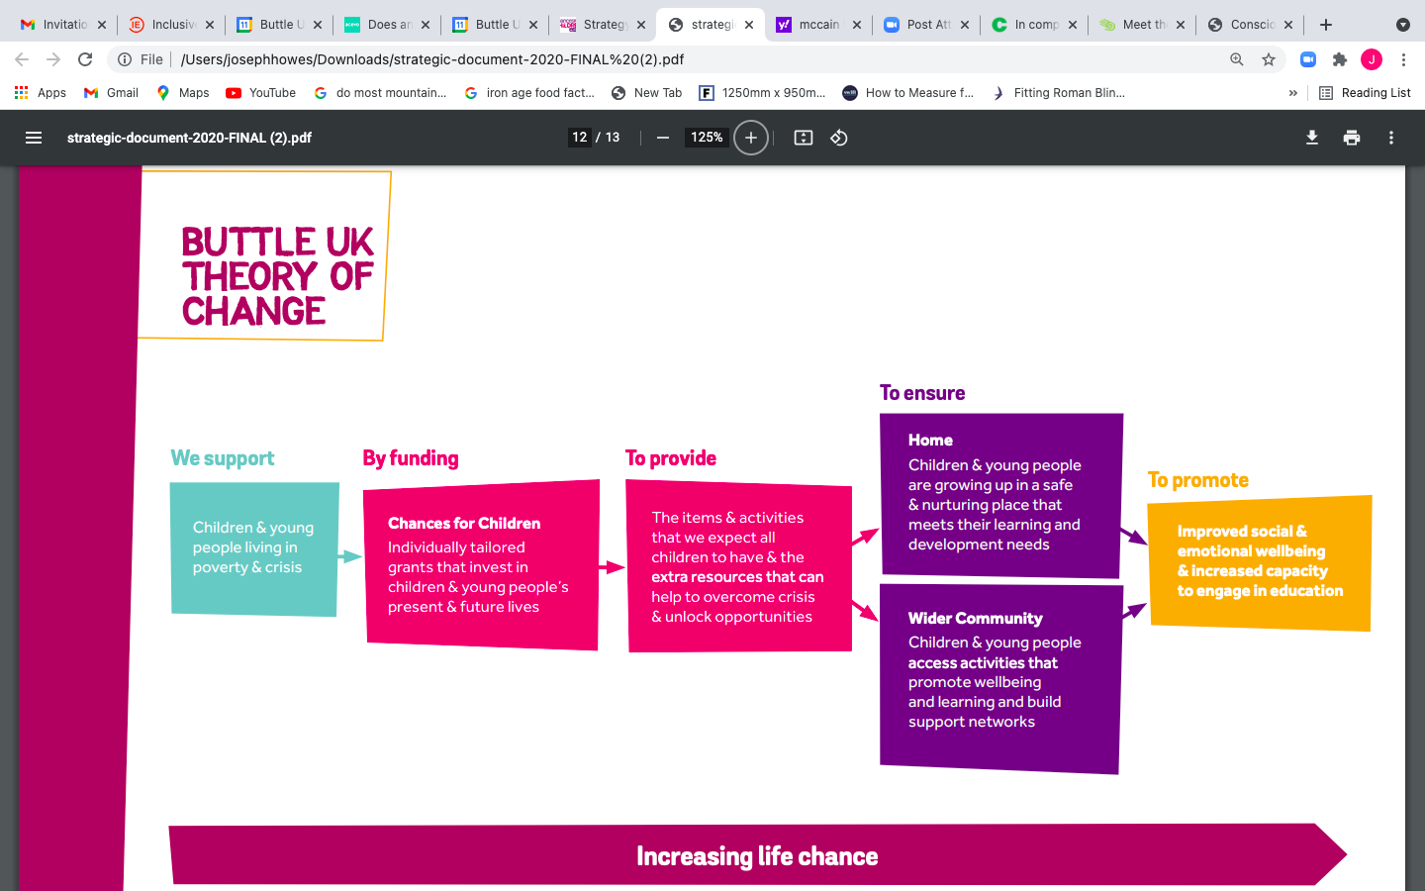

**Our Commitment to Equity, Diversity & Inclusion.**

We welcome applications from anyone regardless of their age, experience, disability, ethnicity, heritage, sexuality, gender and socio-economic background. **We particularly encourage applications from black, Asian, and minority ethnic candidates** as these groups are strongly supported in our grant-making but underrepresented within our organisation.

To support anyone looking to apply for our trustee positions we commit to:

* Paying for childcare for the hours in and around the interview process
* Paying for your travel costs to the office and back for interviews if these are held in person.
* Making any reasonable adjustments to support your needs in the application and interview process.

**Read more about our commitment to equity, diversity and inclusion across our organisation**[**here**](https://buttleukprod.wpengine.com/equity-diversity-and-inclusion/)

**Buttle UK Background Reading, Listening & Viewing**

For further information about our grant programmes and wider work please access on our website:

* READ - The history of Buttle UK - <https://buttleuk.org/what-we-do/our-work/our-history/>
* READ - Annual Review and Accounts - <https://buttleuk.org/what-we-do/our-services/annual-reports/>
* READ – Our 2020-25 Strategy - <https://buttleuk.org/what-we-do/our-services/strategy-mission-values/>
* READ - Our State of Child Poverty 2023 Report - <https://buttleuk.org/news/news-list/state-of-child-poverty-2023/>
* WATCH - Our video explaining our Chances for Children Grants - <https://www.youtube.com/watch?v=2ZCAMgdZoos&t=64s>
* LISTEN – Our range of podcasts we have produced highlighting the issues and challenges children in crisis our facing today - [All in the Same Boat? - Buttle UK](https://buttleuk.org/news/all-in-the-same-boat/)
* READ - The story of others that have benefited from Chances for Children grants - <https://buttleuk.org/support-us/stories/>

**Our Benefits**

* Salary of **£65,208 - £70,699**per year pro-rata depending on skills and experience
* Flexible working conditions, the current SMT generally come to the office two days a week.
* Generous annual leave entitlement – 28 days plus Bank Holidays
* Employer contribution to pension scheme – 7%
* Life assurance scheme
* Enhanced maternity/paternity leave
* Enhanced sick pay
* Employee Assistance Programme: counselling and support for staff members wellbeing
* Two volunteering days per annum
* Career growth and development opportunities through our commitment to learning
* Other financial benefits: interest free season ticket loan provision; eye test payment and up to £100 payment to purchase glasses; access to CycleScheme.
* Please see full benefits package attached here

**How to apply**

Buttle UK are partnering with Valued Recruitment, an inclusive recruiter who is unafraid to represent the real you. If you would like more information about the role, please contact Anna Ludeman at [anna@youarevalued.co.uk](mailto:anna@youarevalued.co.uk) or phone on 07828 288704.

We are keen to recruit in an inclusive way and are very open as to how you would like to apply. We are happy to accept ONE of the following things;

* A CV.
* A 1 page letter letting us know why you would like this role and what you can bring to us here at Buttle UK.
* A short video introducing yourself and telling us why you would like to work at Buttle UK

Please send this to [anna@youarevalued.co.uk](mailto:anna@youarevalued.co.uk)

Accessibility is incredibly important to us here at Valued Recruitment and at Buttle UK. If you would like any accessibility amendments or support throughout the application and interview stage, please don’t hesitate to let us know. No question or request is too big or too small. We want this process to be comfortable and enjoyable and a chance for you to bring your best self to the process.

**Recruitment timetable**

|  |  |
| --- | --- |
| **Activity** | **Date** |
| **Closing date for applications** | **Monday, 30th October, 1200 noon** |
| **Shortlisting** | **W/c 30th October** |
| **Interviews – first stage (virtual)** | **W/c 6th November** |
| **Interviews – second stage (in-person)** | **W/c 13th November** |

The appointment will be made subject to satisfactory references.